Experiment 6: Weather Data Analysis (Temperature Analysis)

Objective : Analyze temperature data to find the hottest and coldest days using MapReduce. Dataset (Create This)

Procedure
Step 1: Create Dataset
cat > weather_data.txt << 'EOF'
2024-01-01,Delhi,12,5
2024-01-02,Delhi,14,6
2024-01-03,Delhi,10,3
2024-01-04,Mumbai,28,20
2024-01-05,Mumbai,30,22
2024-01-06,Bangalore,25,18
2024-01-07,Bangalore,26,19
2024-01-08,Chennai,32,25
2024-01-09,Chennai,33,26
EOF

Step 2: Expand Dataset
for i in {1..100}; do cat weather_data.txt; done > weather_large.txt

Part A: Mapper Code (Extract Max Temperature)
cat > mapper_max_temp.py << 'EOF'
#!/usr/bin/env python3
import sys

for line in sys.stdin:
line = line.strip()
if not line:
continue

parts = line.split(',')
if len(parts) != 4:
continue

try:
date = parts[0]
max_temp = float(parts[2])

print(f"{date}\t{max_temp}")
except ValueError:
continue
EOF
chmod +x mapper_max_temp.py

Part B: Reducer (Hottest Day)
cat > reducer_max_temp.py << 'EOF'
#!/usr/bin/env python3
import sys

max_temp = -float('inf')
hottest_date = None

for line in sys.stdin:
line = line.strip()

if not line:
continue

date, temp = line.split('\t')
temp = float(temp)

if temp > max_temp:
max_temp = temp
hottest_date = date

if hottest_date is not None:
print(f"Hottest Day: {hottest_date} with {max_temp}°C")
EOF
chmod +x reducer_max_temp.py

Part C: Run Hadoop Job (Hottest Day)
Upload data
hdfs dfs -mkdir -p /user/$USER/weather/input
hdfs dfs -put weather_large.txt /user/$USER/weather/input/
Run MapReduce
hadoop jar $HADOOP_HOME/share/hadoop/tools/lib/hadoop-streaming-*.jar \
-input /user/$USER/weather/input/weather_large.txt \
-output /user/$USER/weather/output \
-mapper "python3 mapper_max_temp.py" \
-reducer "python3 reducer_max_temp.py" \
-file mapper_max_temp.py \
-file reducer_max_temp.py
View Output
hdfs dfs -cat /user/$USER/weather/output/part-00000
Part D: Reducer (Coldest Day)
cat > reducer_min_temp.py << 'EOF'
#!/usr/bin/env python3
import sys

min_temp = float('inf')
coldest_date = None

for line in sys.stdin:
line = line.strip()

if not line:
continue

date, temp = line.split('\t')
temp = float(temp)

if temp < min_temp:
min_temp = temp
coldest_date = date

if coldest_date is not None:
print(f"Coldest Day: {coldest_date} with {min_temp}°C")
EOF
chmod +x reducer_min_temp.py

Run Coldest Day Job
hdfs dfs -rm -r -skipTrash /user/$USER/weather/output_min

hadoop jar $HADOOP_HOME/share/hadoop/tools/lib/hadoop-streaming-*.jar \
-input /user/$USER/weather/input/weather_large.txt \
-output /user/$USER/weather/output_min \
-mapper "python3 mapper_max_temp.py" \
-reducer "python3 reducer_min_temp.py" \
-file mapper_max_temp.py \
-file reducer_min_temp.py
View Output
hdfs dfs -cat /user/$USER/weather/output_min/part-00000
ScreenShot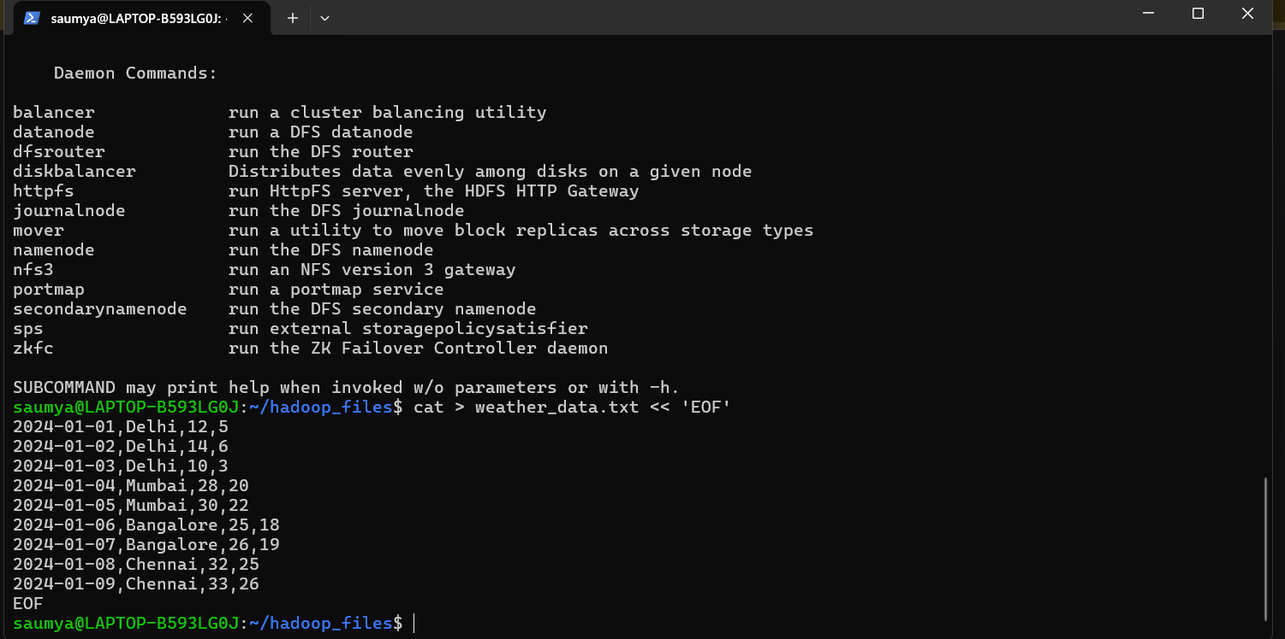
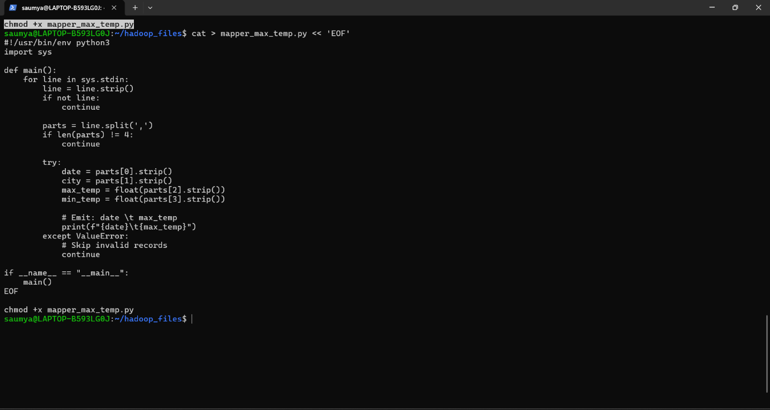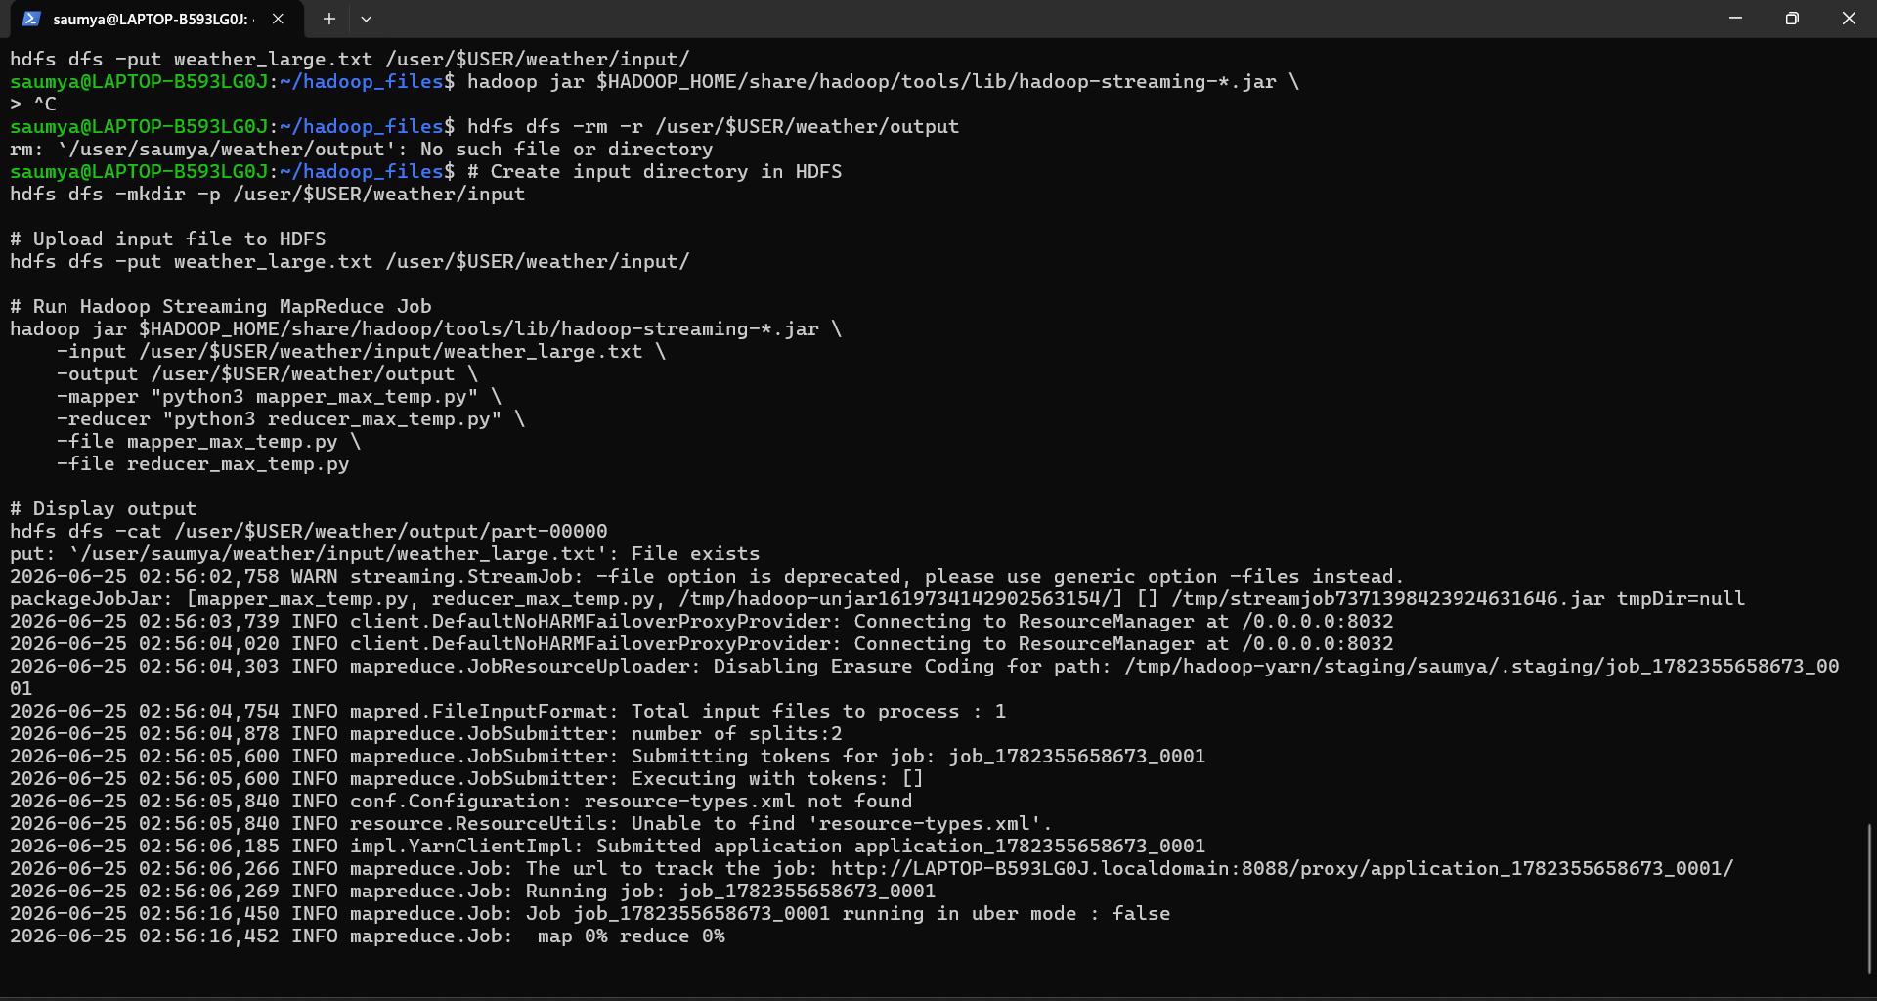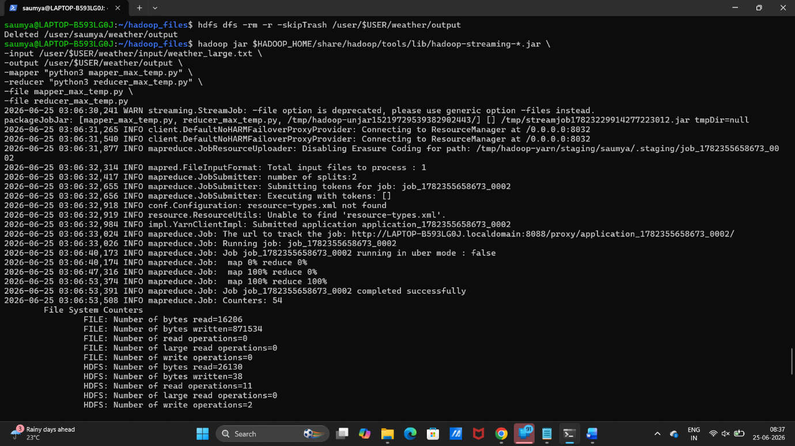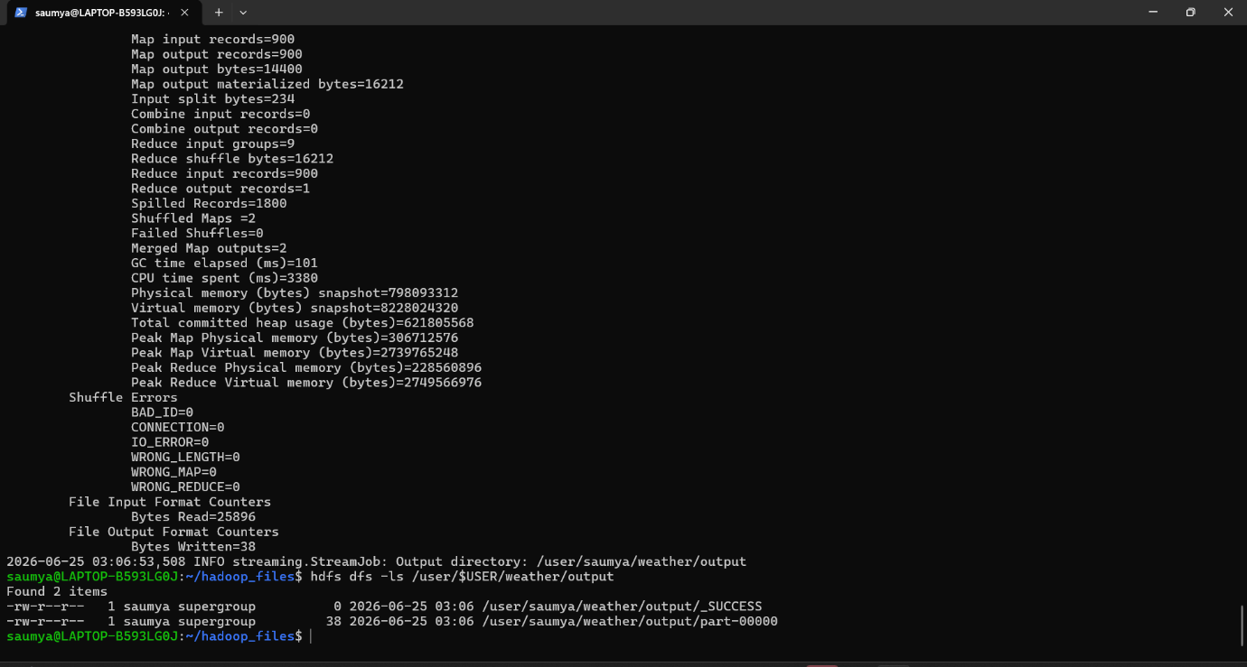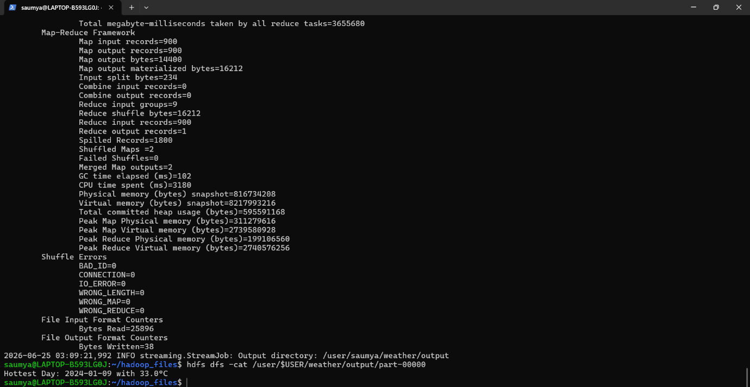
Conclusion
In this experiment, we successfully implemented a MapReduce-based weather data analysis system using Hadoop Streaming.
Key Outcomes:
- Extracted maximum temperature per day using Mapper-Reducer model.
- Identified the hottest day in the dataset.
- Identified the coldest day using a separate reducer.
- Learned how distributed processing works using Hadoop.
Learning:
- Mapper processes raw input and emits key-value pairs.
- Reducer aggregates and computes final results.
- Hadoop Streaming allows Python integration with Hadoop.

